# How to make a Menu in Unity

Step 1:

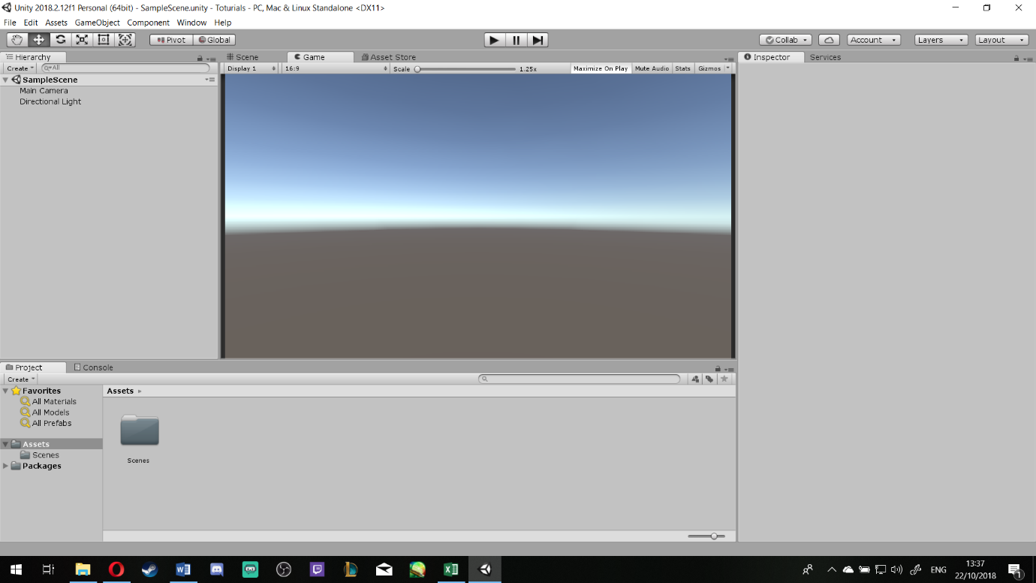**Open Unity >** Create a Scene (other than your Level1 Scene)

***Step 2***:

Go to **GameObject** > **UI** > **Image**

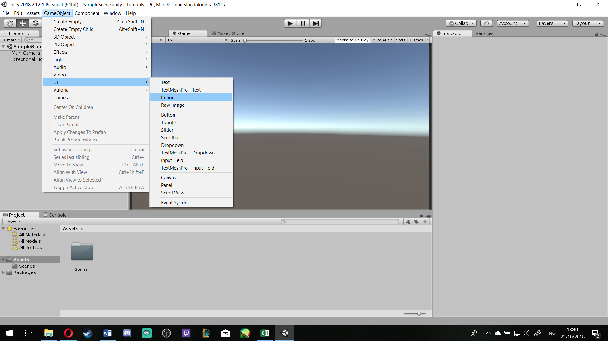

It will automatically create a Cavas with a sub file called Image (as showed below [ASB])

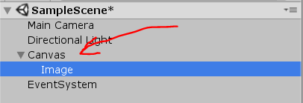

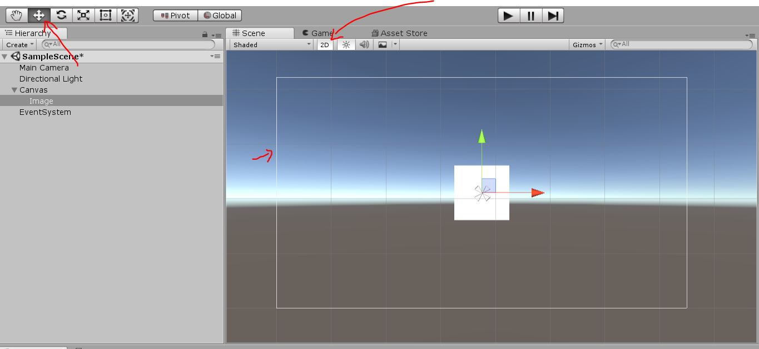(Quick pointers: to make your life easier, make sure your view is on **2D** and the **frame of canvas** is in your view (that’s the big white boarder) and you can use the tools on the top side to help you navigate around the canvas) [ASB]

To make your life easier: Create a folder in you **Asset** file and call it **Materials**, and then another folder called **UI Images**, there you can upload all the pictures you are intending to use for your UI images. To make a new folder, right click on your **Asset** folder > **Create** > **Folder** [ASB]

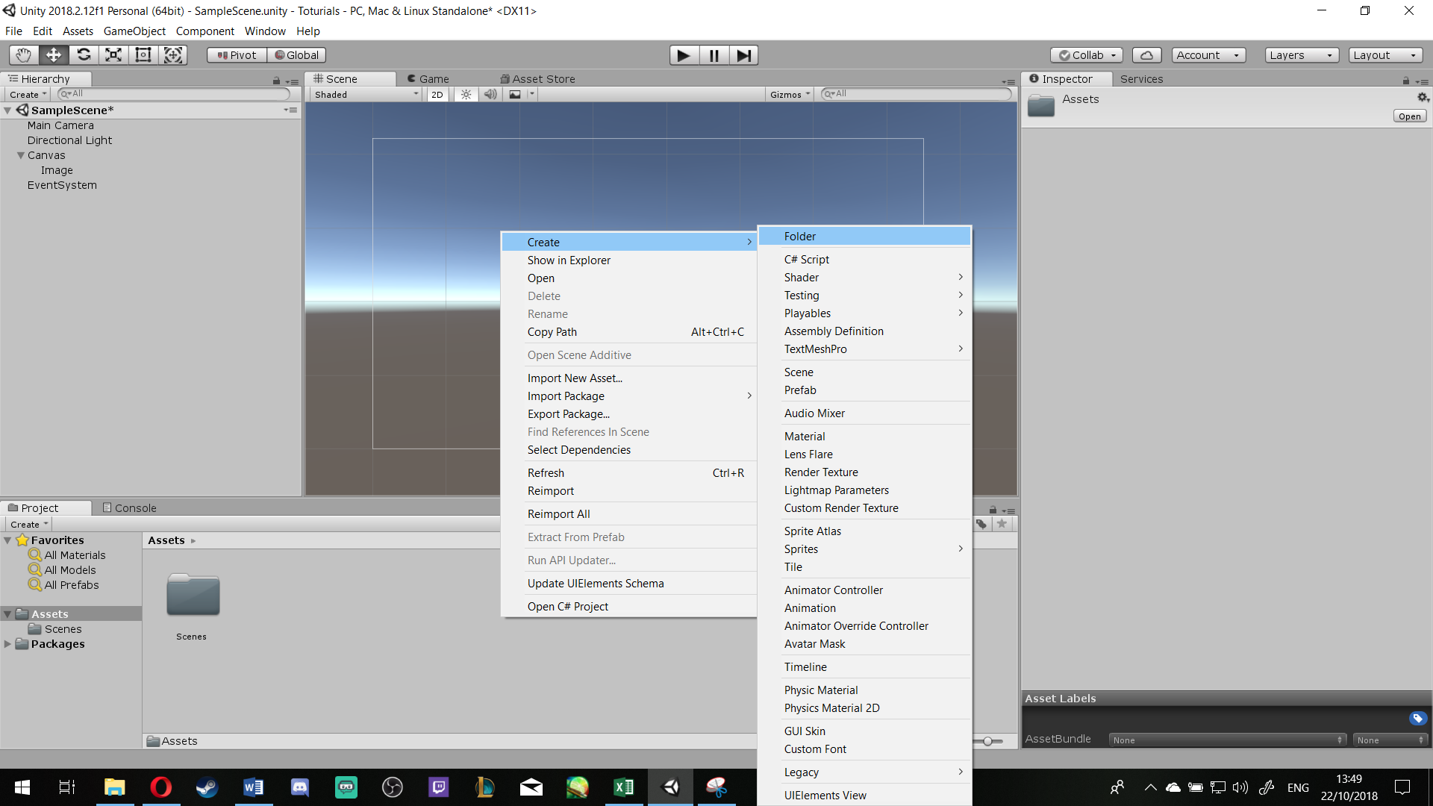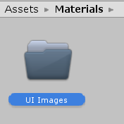

**To import your Images**: Inside UI Images, right click and select ‘**Import New Asset**’

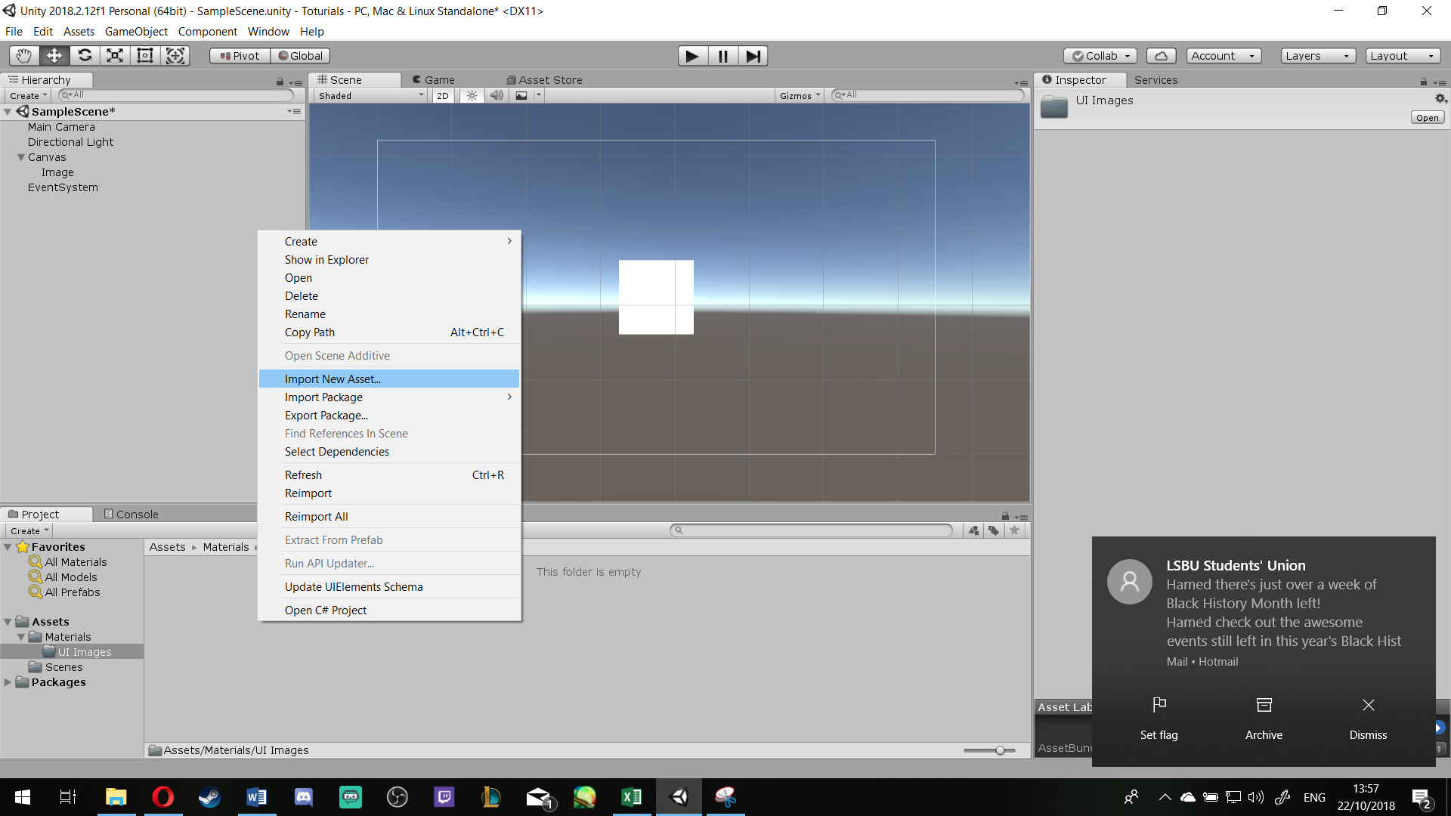

Then a browser folder opens, go to the directory that you are keeping your images, select all the images you like to use, then > **Import** [ASB]

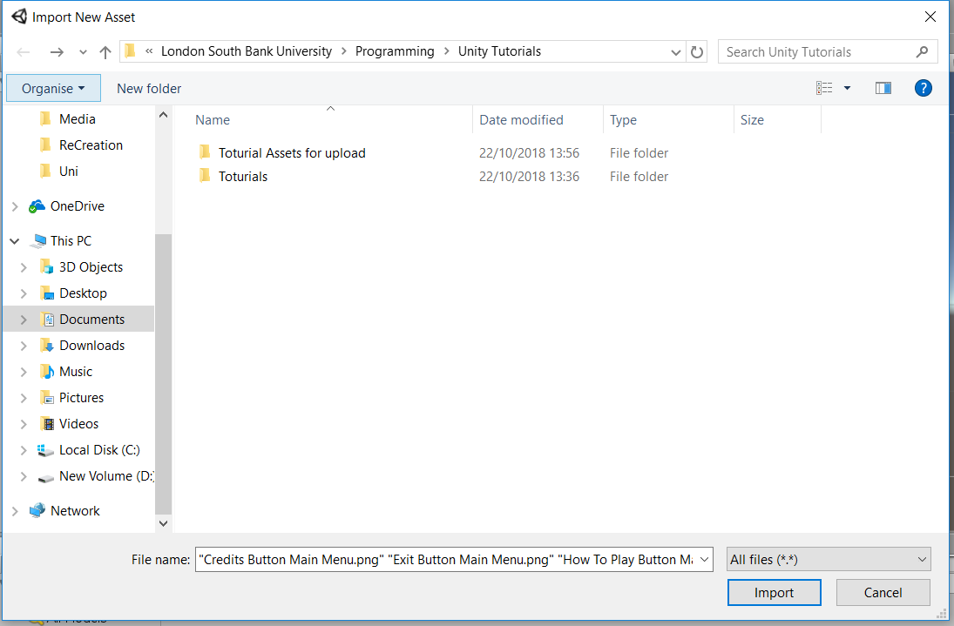

To add any sort of image transparency and make it easier to upload and edit, Select the image you want to use, On the **Inspector** section, under the **Texture Type**, select **Sprite (2D and UI)**, then press **Apply** [ASB]

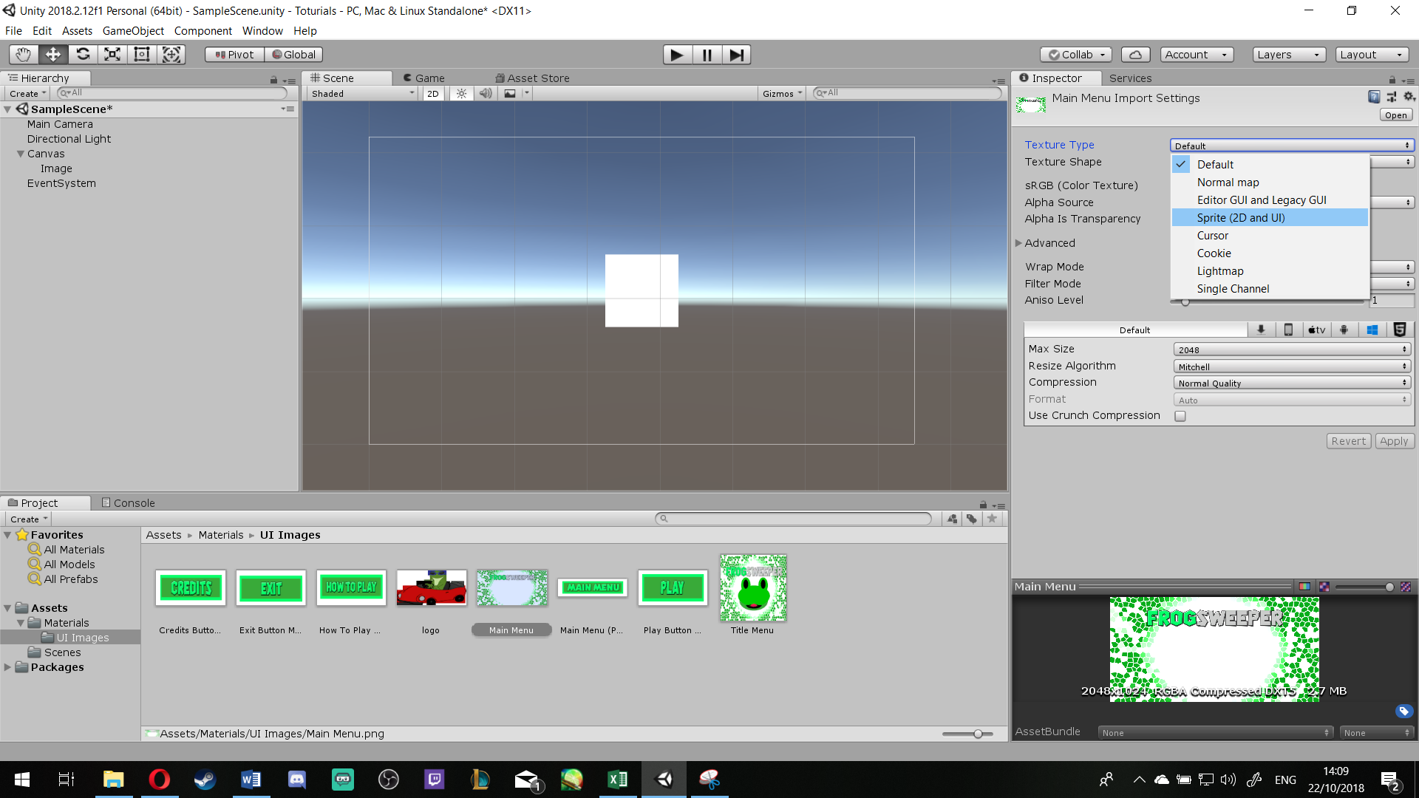

***Step 3***:

Click on Image, then **Drag** the Image you like to add to your Menu from your **UI Images** folder, and **Drop** it on **Source Image** under **Image (Script)** in **Inspector** [ASB]

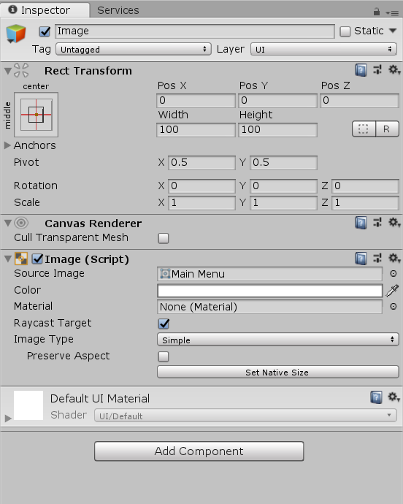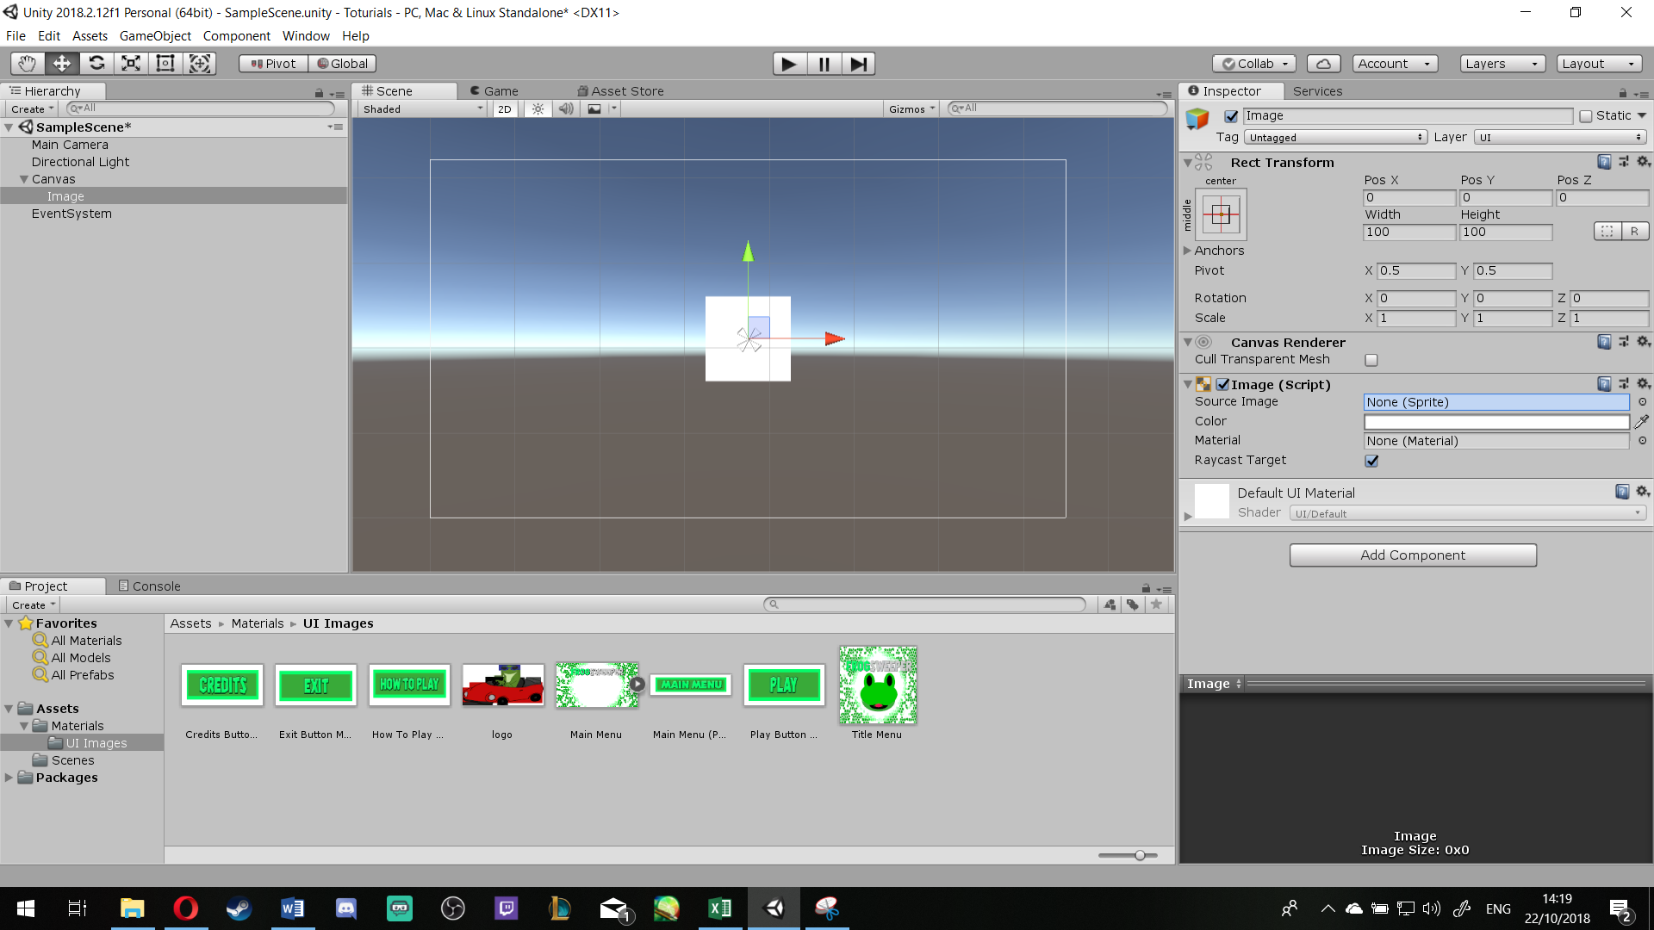

To make the image same Aspect and quality as original image, in **Inspector**, **Image (Script)** make sure **Preserve Aspect** is ticked and click **Set Native Size**, then press the **R** key and re-size, **W** to move, **E** to Rotate the image to your liking [ASB]

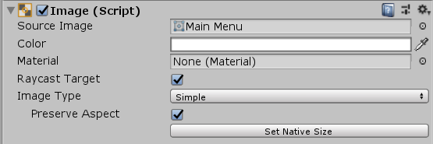

To make your life easier: change the name of the Image at either **Hierarchy** or **Inspector** to appropriate name.

***Step 4***:

In your **Hierarchy**, right click on **Canvas** > **UI** > **Panel** [ASB]

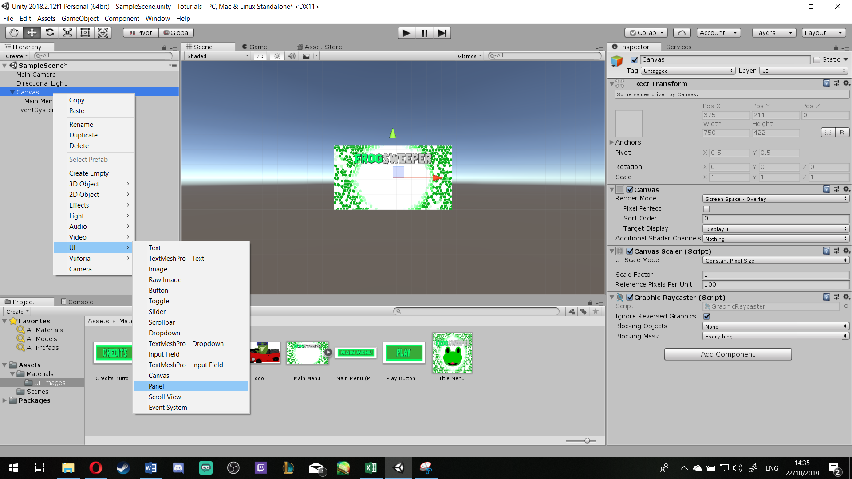

This will make a Panel under your Canvas that would look like a new layer on your ‘Menu’ and it has tiny triangles on its corners, move them around to your likings so the panel sets up a position for your up-coming screens and buttons, then Select Panel again and change its size, rotation and position to your liking as well [ASB]

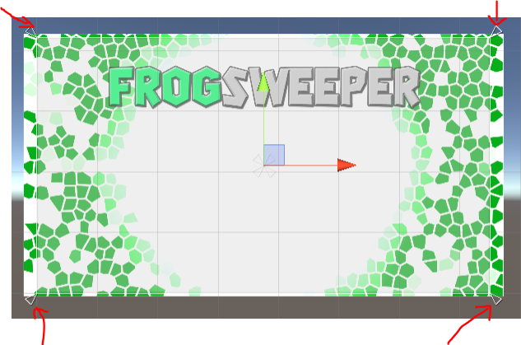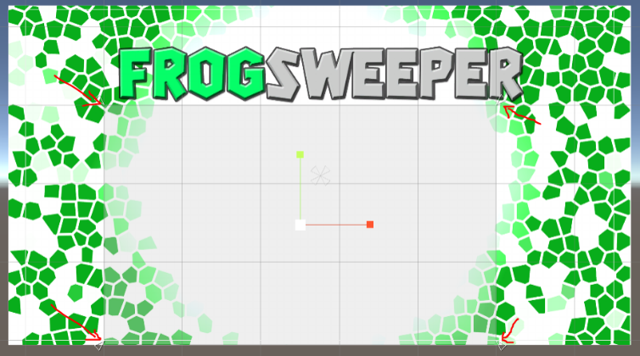

To make your life easier: Re-Name your **Panel** to **Main Menu Panel**

***Step 5***:

Right click **Main Menu Panel** > **UI** > **Button** This will create your first button with Text on it; if you have a pre-designed Button (like I do for this Tutorial) then delete the sub-file called Text, if not click the Text, Under Text Script, you can edit the text to what you wish. [ASB]

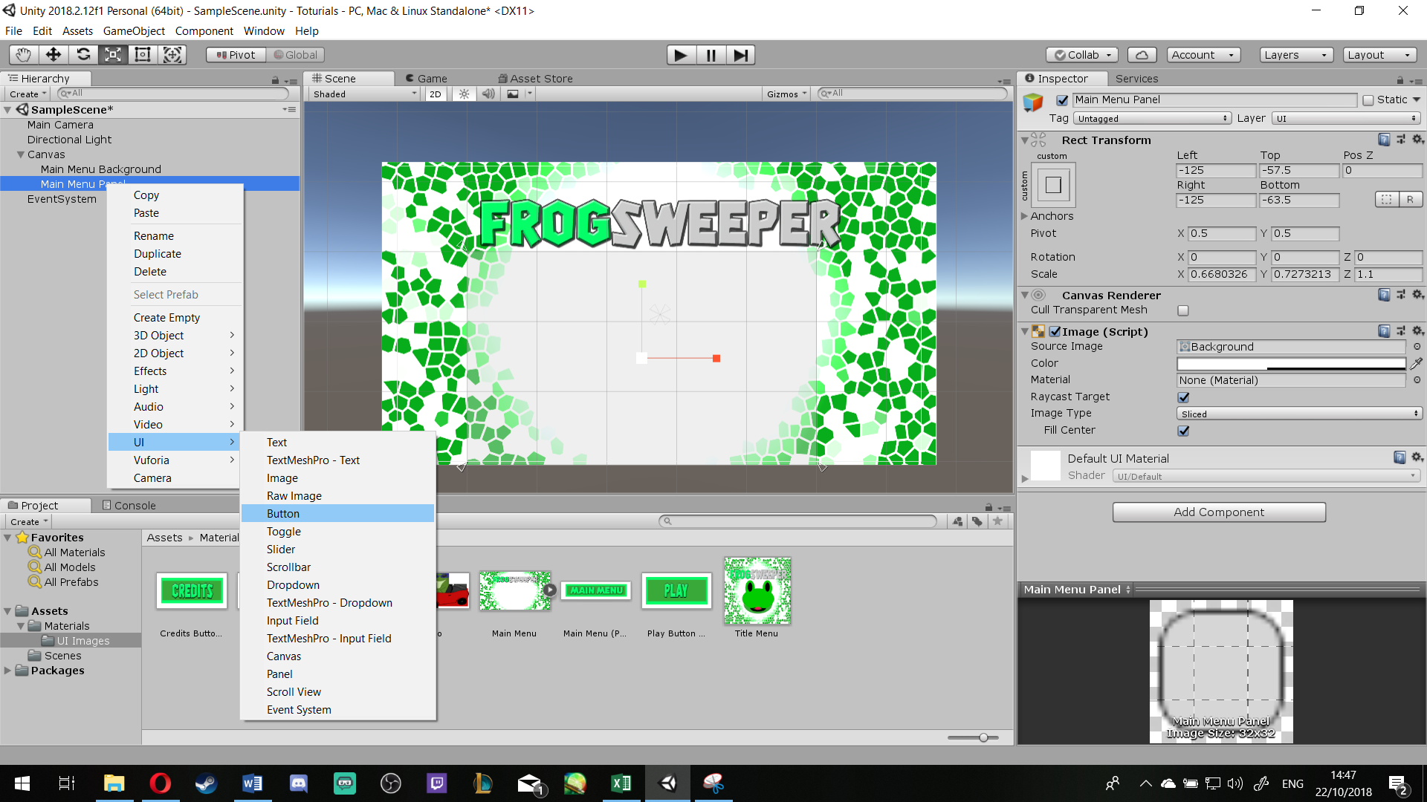

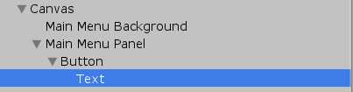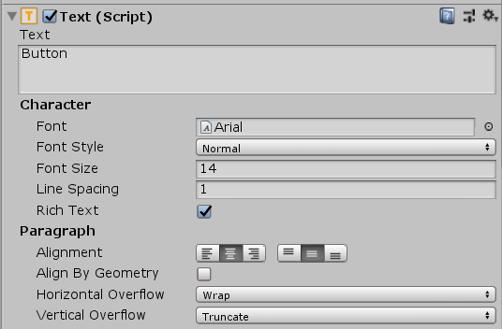

Then Select your Button and move it according to your likings

***Step 5.1/2***:

If you are using Image for your button, process is same as **Step 2 and Step 3**

To make your life easier: Make sure you re-name your Button name, i.e PlayButton

***Step 6***:

Do steps 4 & 5 until you have **all the Buttons you need** for your **Main Menu** [ASB]

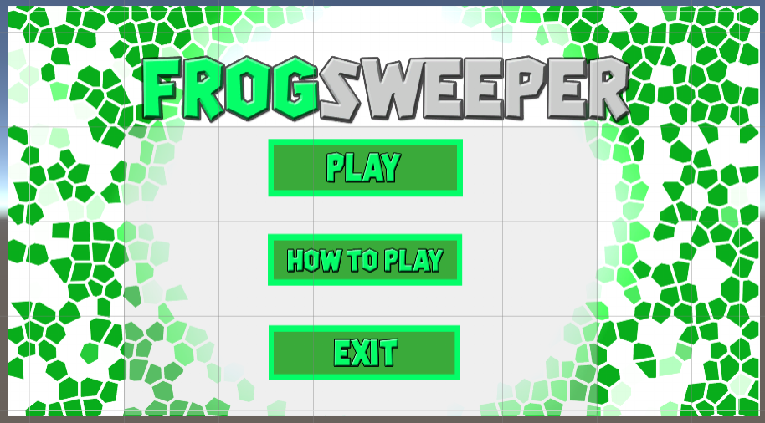

***Step 7***:

Right Click **Main Menu Panel** > **Duplicate** [ASB]

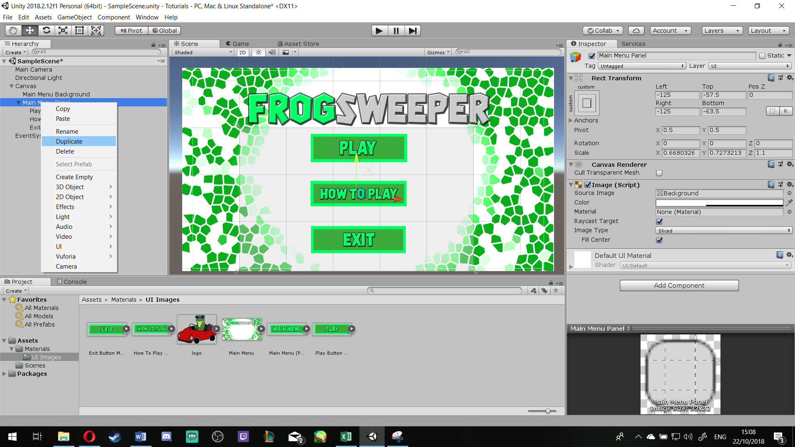

To make your life easier: Re-name it to **How to Play Panel**

Click **Main Menu Panel** again, then **untick** the box next to its name at the **Inspector** [ASB]

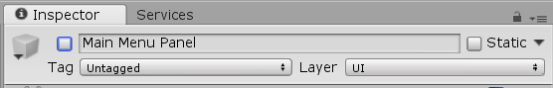

Under the sub items of **How to Play Panel**, only keep one Button and delete the rest [ASB]

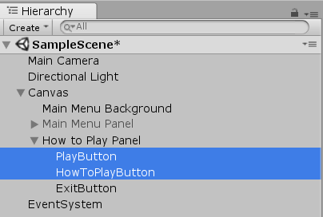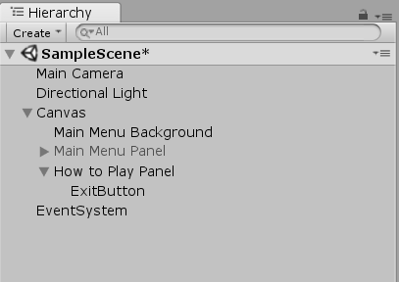

To make your Life easier: Rename that to MainMenuButton

***Step 8***:

Right Click **How to Play Panel** > **UI** > **Text**

Then click on the **Text** in the Hierarchy then **press T**, then re-size it to your liking. You can edit its text, Font size and style, etc. at Inspector [ASB]

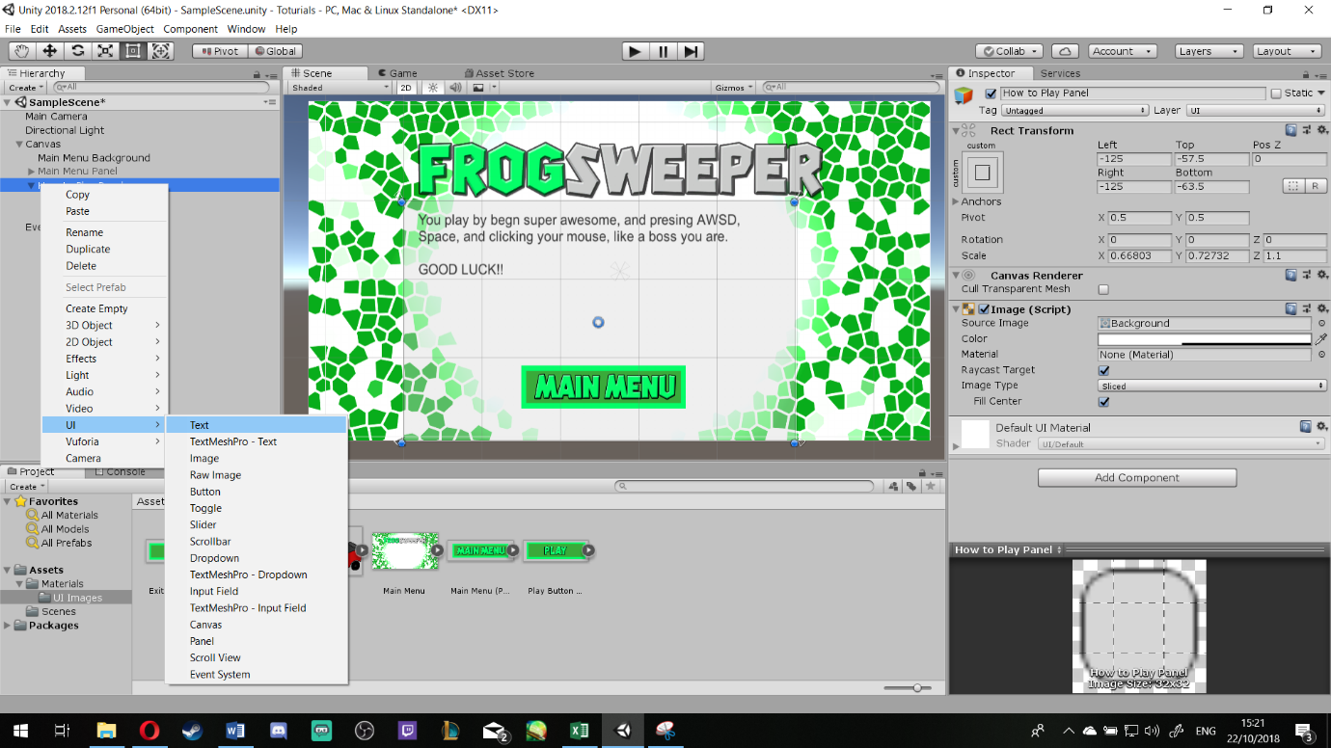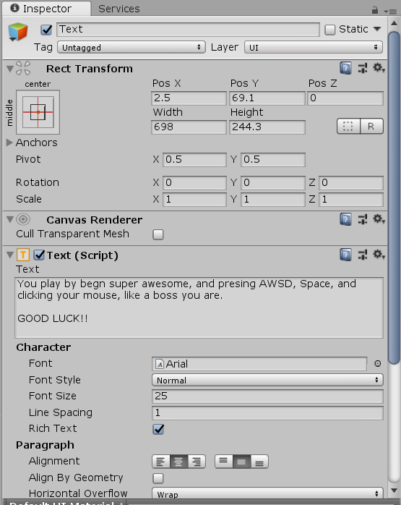

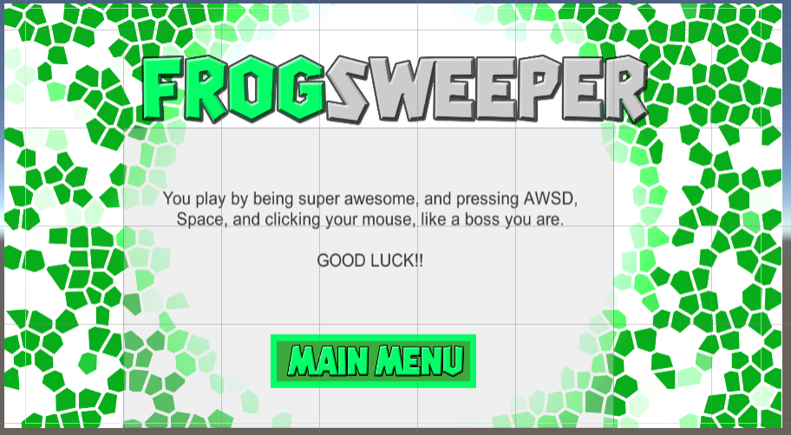

***Step 9***:

Go to Assets Folder and make a new folder called **Scripts**

In the Scripts folder, right click > **Create** > **C# Script**

To make your life easier: call it **ButtonManagers**

Open it, you should have a pre-set script like the following:

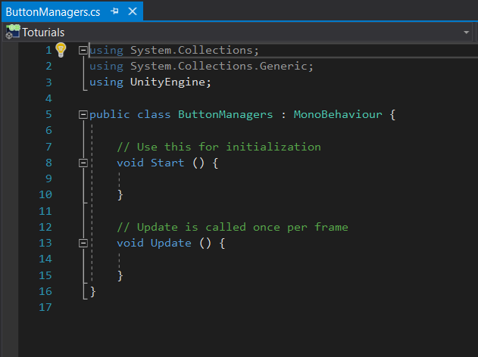

Underneath the using UnityEngine; code, **write**:

using UnityEngine.SceneManagement;

Then **delete** both Void start and Void Update code [ASB]

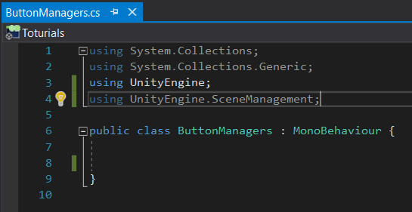

Instead of the void statements, **write** the following:

public void NewGameBtn(string newGameLevel)

{

SceneManager.LoadScene(newGameLevel);//This will load the next scene when called upon

}

So, it will be like this:

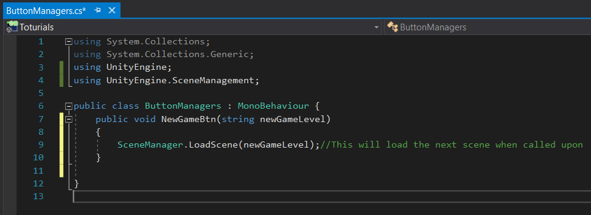

Then **Press** Ctrl+Shift+S or press **Save all** [ASB]

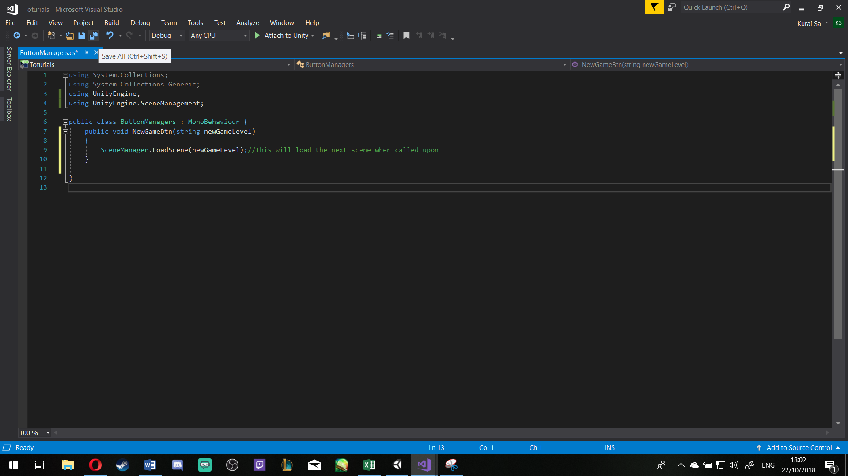

***Step 10***:

For the Exit, Add the following code straight after Step 9:

public void ExitGameBtn()

{

Application.Quit();

}

So overall it would look like this:

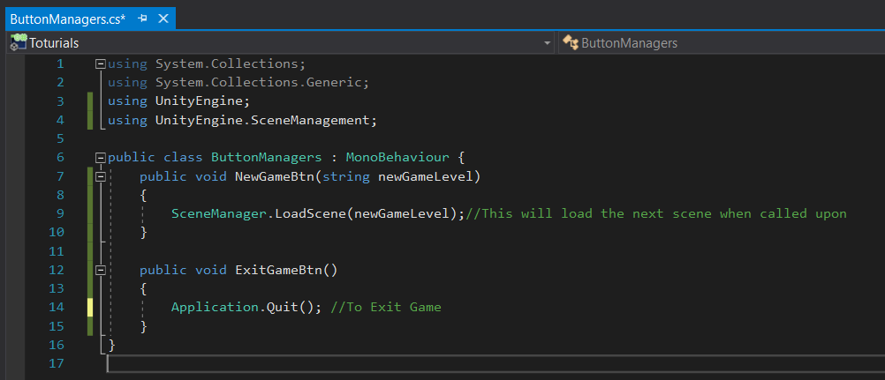

Then **Save All** and Close the script.

***Step 11***:

Go back to **Unity** > **Canvas** > **Right click** -> **Main Menu Panel** > **Create Empty**

To Make your life easier: Re-Name it to ButtonManger

**Drag** the Script ButtonManager and **drop** on to it [ASB]

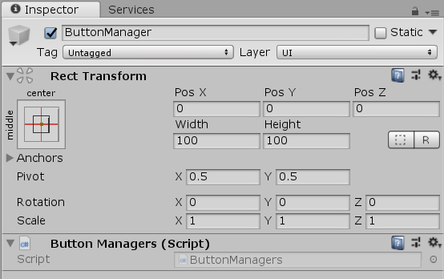

***Step 12***: Go to PlayButton

Then in **Inspector** > **Button (Script)** > **On Click ()** > **list is empty**, there should be a plus sign on the right-hand side, click it [ASB]

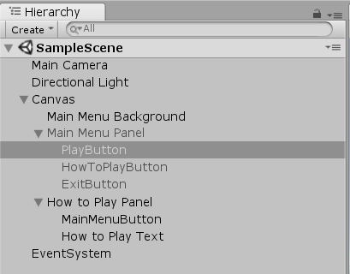

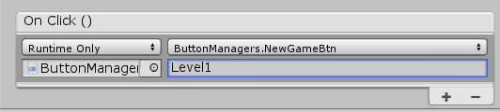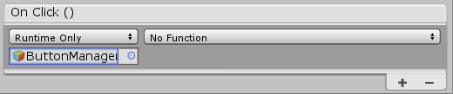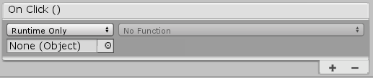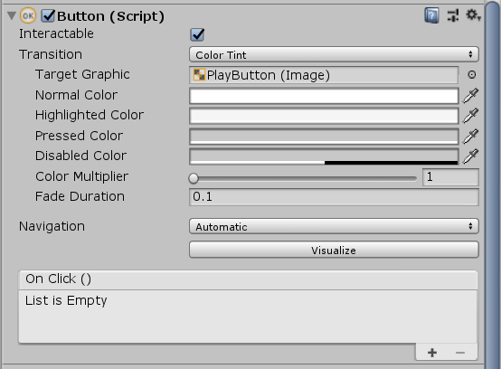

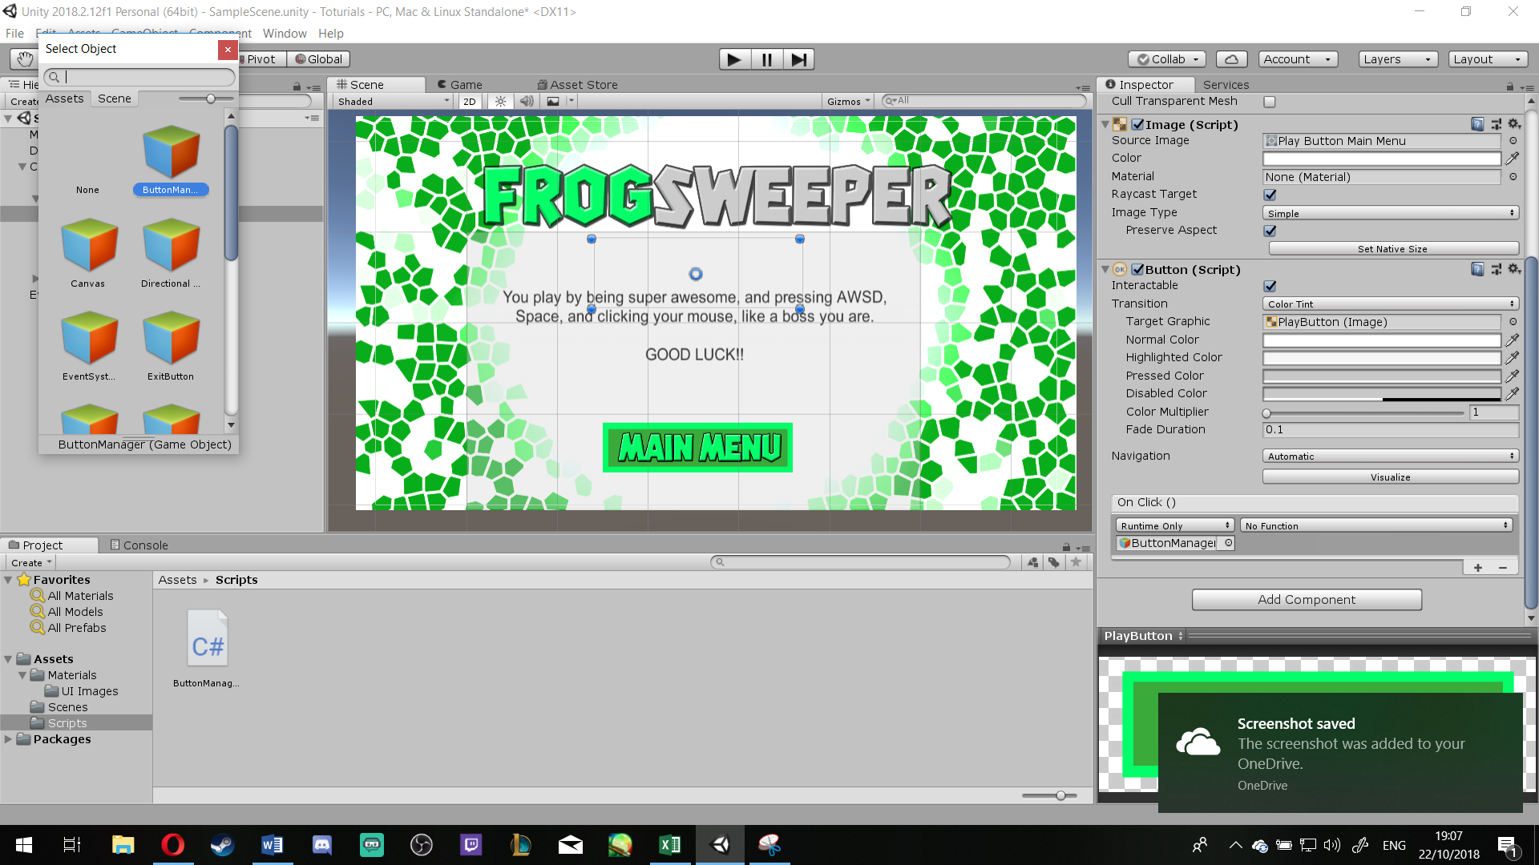Then **click** the little circle next to None (Object), When you do a new window opens, then click **Scene**, then choose the **Button Manager** [ASB]

Then press **No Function** > **ButtonManagers** > **NewGameBtn (string)** [ASB] Then in the box provided, write the name of the Scene that you want your Play button to be redirected at i.e. Level1.

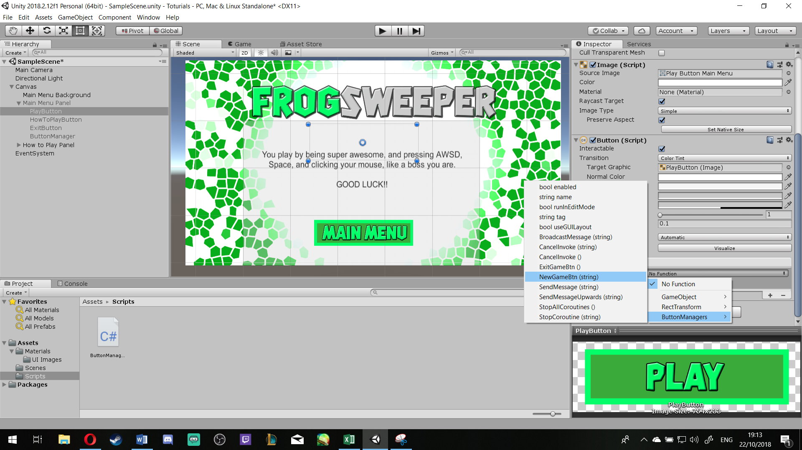

***Step 13***:

Either Press Ctrl+Shift+B or go to **File** > **Build Settings**… [ASB]

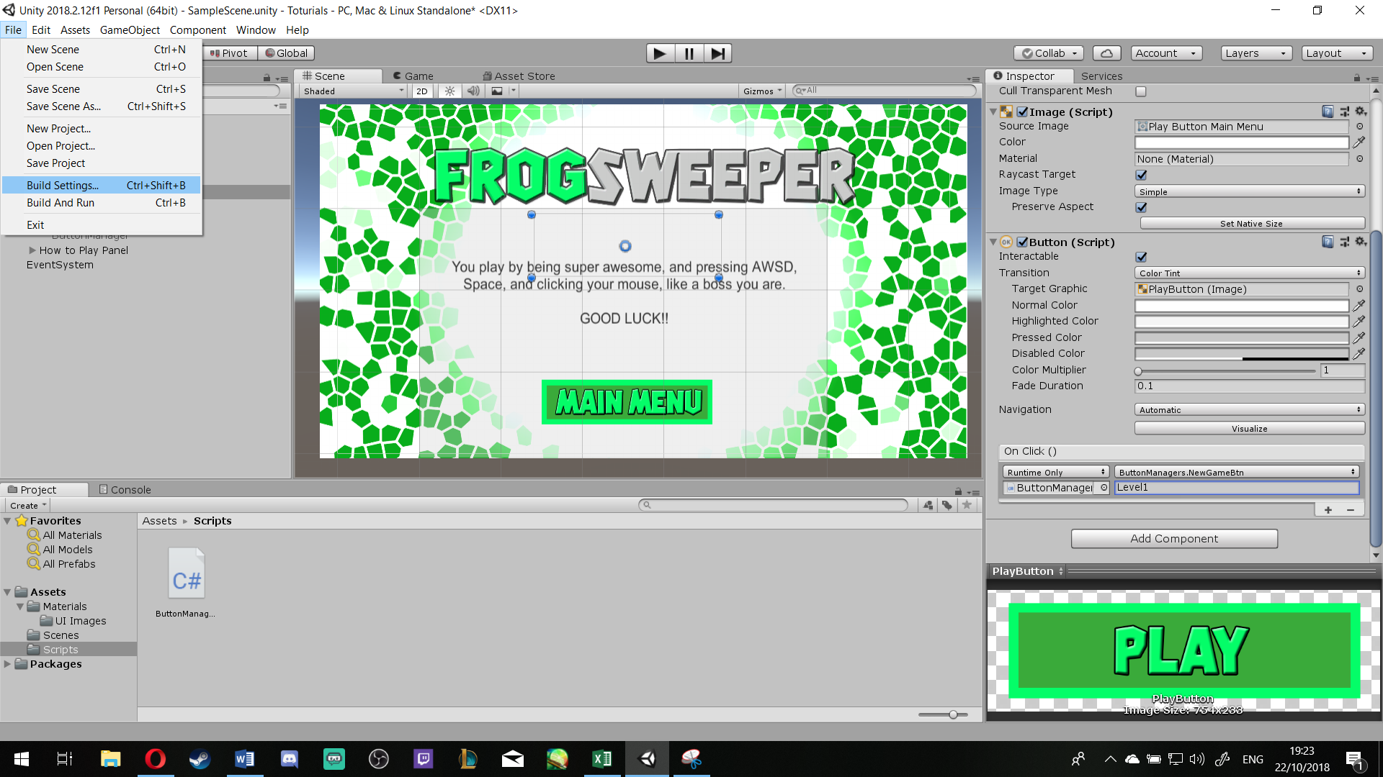

To Make your life easier: Open **Assets** > **Scenes** before you do the above

Then **Drag** and **Drop** the Scene of your Next level and make sure it is positioned After your **Menu Scene** [ASB] And then you can close the Build Settings window.

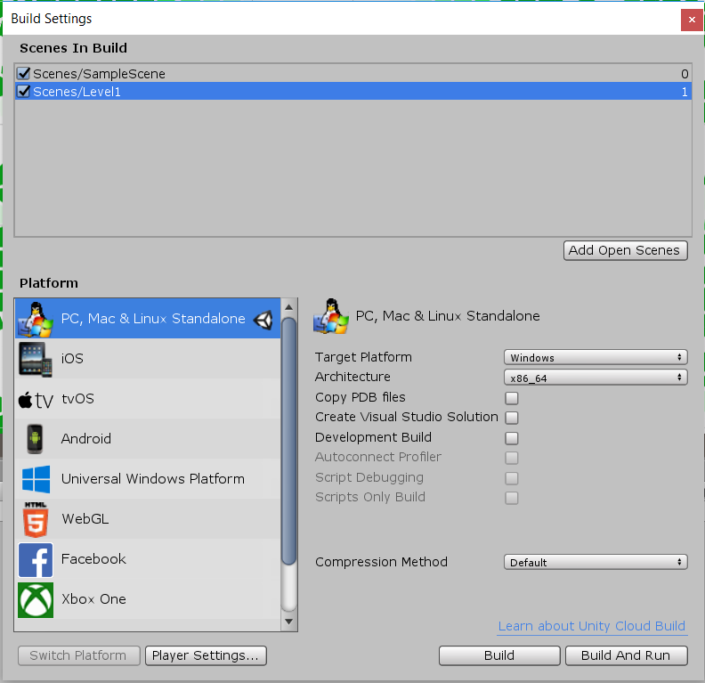

***Step 14***: Re-peat **step 12** till the below section for the **How to Play Button**



Then **Drag** the Main Menu Panel and **Drop** it on the **None (Object)**, Then press the **No Function** > **GameObject** > **SetActive (bool)** [ASB]

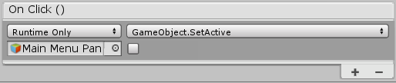

Then **Press** the (+) **plus** again, and do the same but **drag** and **drop** the **How to Play Panel** instead and tick the box in front of it [ASB]

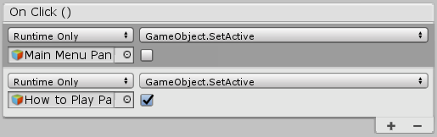

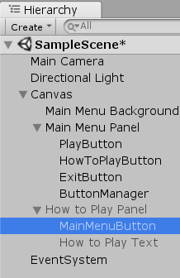***Step 15***: Do the reverse of **Step 14** on the **Main Menu Button** [ASB]

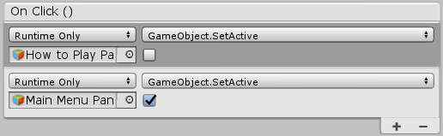

Make Life easier for you: make sure the Main Menu Panel is now visible and the How to play Panel is not by pressing the tick next to its name as it was shown before previously.

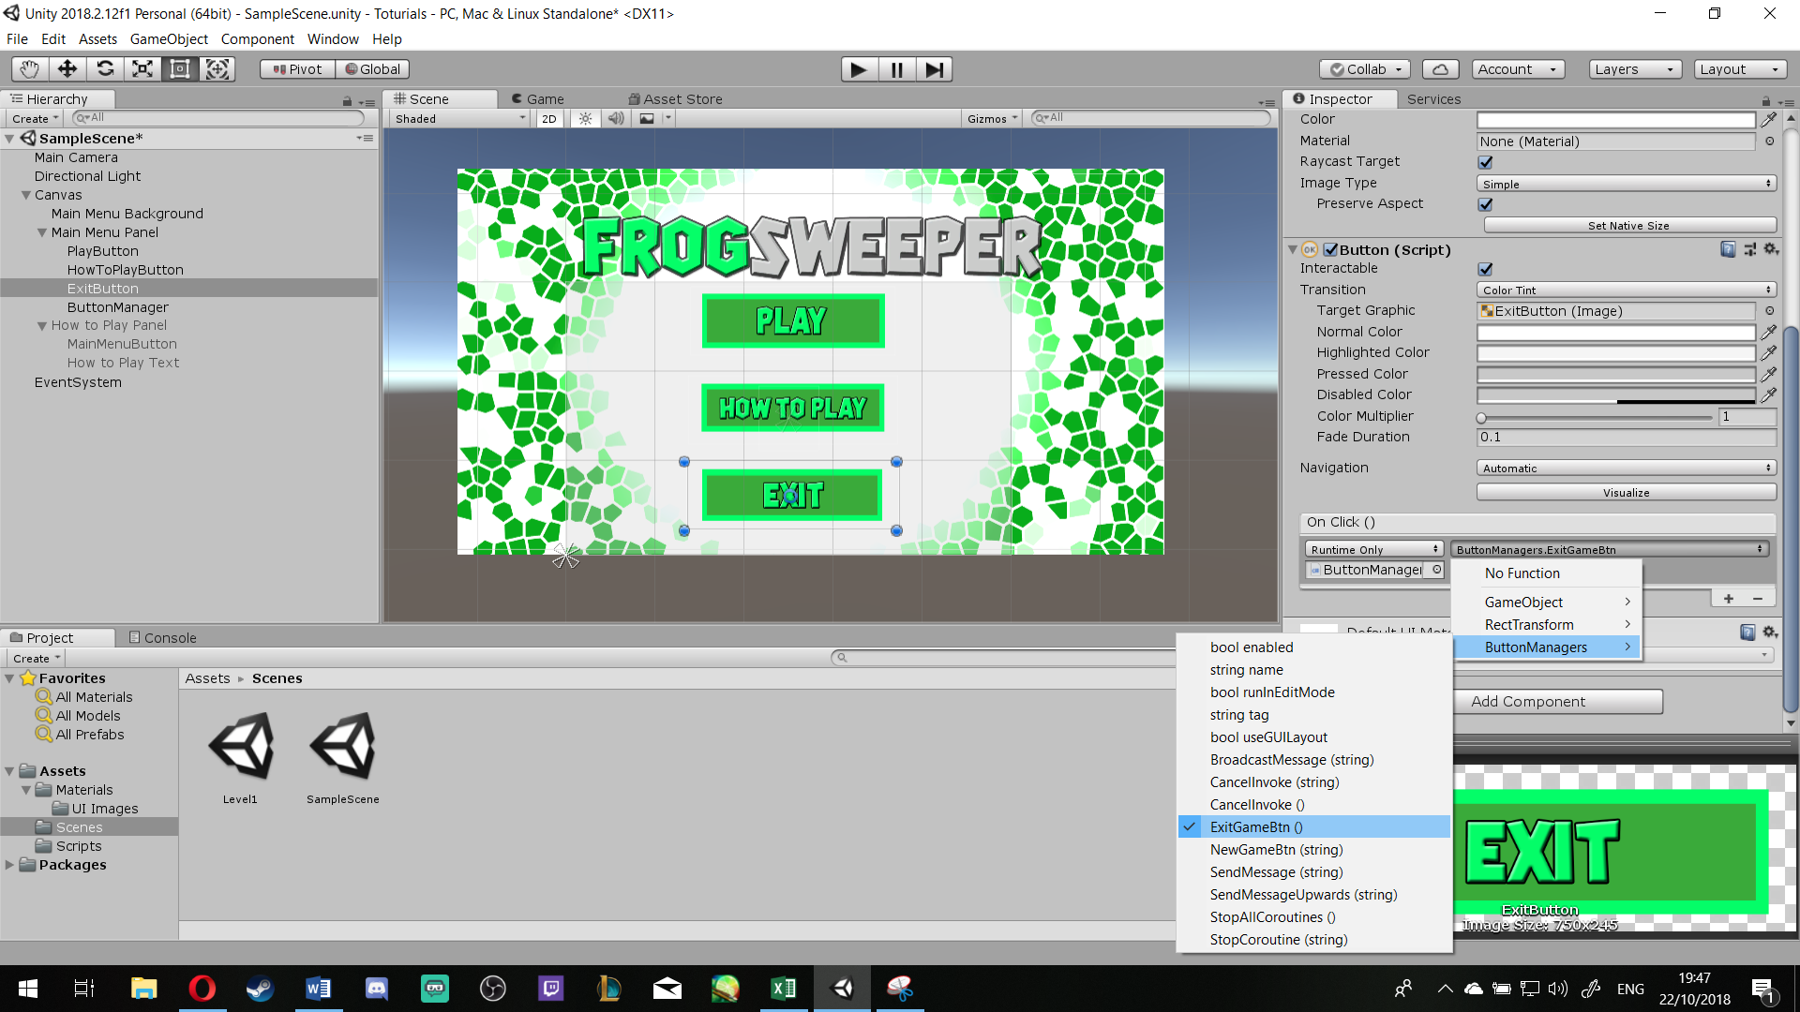***Step 16***: As for Exit Button, after pressing on it, in the **Inspector**, re-peat step 12, but in the **ButtonManagers**, instead of NewGameBtn (String) Select the option above, the ‘ExitGameBtn ()’ [ASB]

***Step 17***: ***Save your work***,

Make your Life Easier: **Repeat** Step 17 **from step 1 till step 16**